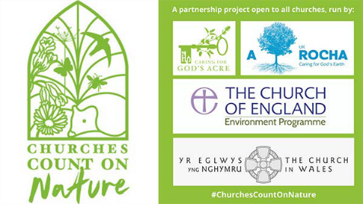
RECORDING SHEET
WHERE: name of burial ground St. Michaels & All Angels Cofton Hackett

WHO (your name)  & email if you are happy to share it | WHAT did you see? | WHEN you saw it
Douglas Allenby  da@landscape-matters.co.uk | Trees – Pedunculate Oak, Bird Cherry, Wild Cherry, Beech, Sycamore, Silver Birch, Scots Pine, Tulip tree, Lawson Cypress, Wych Elm, Horse Chestnut, Purple Beech, Norway Maple, Ash, Holly, Leylandii, Red Oak, English Yew, Hornbeam, Rowan, Irish Yew, Rhus typhina, dwarf conifer, Common lime. | 10.06.23  (and over last 5 years)
 | Recently planted traditional fruit trees (17 No.) – Black Worcester pear, Doyenne du Comice pear, Purple Pershore plum and Victoria plum, Oullin’s Gage, Apples – Catshead, Lord Hindlip, Gladstone, Colwall Quoining.
 | Shrubs – Hazel, Hawthorn, Purple Elder, Magnolia, Pieris forestii, Camellia, Hydrangea, flowering rose, Hypericum, Ericas, Hebe, Photinia, Aucuba, Ribes, Ligustrum Aureum, Spiraea, Cotoneaster, Fuchsia, Rhododendron, Azaleas, Mock Orange, Berberis, Elder, Euonymus Silver Queen, Bramble.
Flowers – Bergenia, Aquilegia, Sedum, Geranium, Red Campion, Petty spurge, Hedge woundwort, Ragwort, Common sorrel, Pignut, Daisy, Arum lily, Orange hawkweed, Montbretia, Wood avens, Ransoms, Green alkanet, Hairy bittercress, Bluebell, Bulbous buttercup, Creeping buttercup,
Broad-leaved dock, Dog’s mercury, Foxglove, Garlic mustard, Groundsel,
Flowers cont.
Lesser celandine, Chickweed, Cleavers, Columbine, Cow parsley, Cuckoo flower, Dandelion, Herb-robert, Hogweed, Ivy, Lords-and-ladies, Common nettle, Hoary plantain, Yellow poppy, Barren strawberry, Wild strawberry, Spear thistle, Sowthistle (perennial), Speedwell germander, Speedwell ivy-leaved, Violet sweet, Willowherb rosebay, Woodruff, Buttercup meadow, Forget-me-not, Ground ivy, Hawk’s-beard smooth, Daffodils (various), Snowdrop native, Snowdrop Russian, Mallow common, Ajuga reptans, Allium triquetrum, Chionodoxa, Crocus spring, Cyclamen coum, Cyclamen hederifolium, Dog violet, Hostas, Pulmonaria, Stonecrop, Alchemilla mollis, Ivy-leaved toadflax, Spotted deadnettle, Snowflake, Grape hyacinth, Primrose, Selfheal, Skimmia japonica.
 | Grasses – Yorkshire Fog, Cocks Foot, Timothy, Sweet Vernal Grass.
 | Birds – Blackbird, Robin, Coal tit, Song thrush, Chiff Chaff, Wood pigeon, Great tit, Treecreeper.
 | Animals – mole (hole), badger (scrape), Cabbage white, Red-tailed bumblebee.
Lichen (recorded in 2000) - Scoliciosporum umbrinum, Rhizocarpon reductum, Physcia tenella, Cladonia macilenta, Lecanora albescens,
Buellia aethalea, Psilolechia lucida, Xanthoria parietina, Lecanora muralis auct., Parmelia sulcate, Lecanora dispersa, Candelariella vitellina f. vitelline,
Lepraria incana s. lat., Lecanora conizaeoides f. conizaeoides, Micarea denigrate, Bilimbia sabuletorum, Melanelixia fuliginosa, Rinodina teichophila
Lecanora expallens, Porpidia tuberculosa.
 | Others – various ferns, various fungi in the autumn.

